**ECE 5554 COMPUTER VISION HOMEWORK 3**

**ROHIT MURALI**

**SOLUTION 1**

**CODE:**

import numpy as np

import cv2

import math

pathName = "C:\Data\Software\ECE5554 FA19 HW3 images\VAoutline.png"

MAXCONTOUR = 5000

doLogging = False

def showImage(img, name):

cv2.imshow(name, img)

def saveImage(img, name):

cv2.imwrite(pathName + name + ".png", img)

def GaussArea(pts):

n = len(pts)

area = 0.0

for i in range(n):

j = (i + 1) % n

area += pts[i][0] * pts[j][1] - pts[j][0] * pts[i][1]

area = abs(area) / 2.0

return area

def length(contour, i):

size = contour.shape[0]

if i == size - 1:

l = math.sqrt((contour[i,0] - contour[0,0])**2 + (contour[i,1] - contour[0,1])**2)

else:

l = math.sqrt((contour[i,0] - contour[i-1,0])**2 + (contour[i,1] - contour[i - 1,1])**2)

return l

def theta(contour, i):

size = contour.shape[0]

if i == size - 1:

theta = abs(math.atan((contour[i,0] - contour[i-1,0])/(contour[i,1] - contour[i-1,1])) - math.atan((contour[0,0] - contour[i,0])/(contour[0,1] - contour[i,1])))

else:

theta = abs(math.atan((contour[i,0] - contour[i-1,0])/(contour[i,1] - contour[i-1,1])) - math.atan((contour[i+1,0] - contour[i,0])/(contour[i+1,1] - contour[i,1])))

return theta

def onePassDCE(contour):

size = contour.shape[0]

rele = []

for i in range(size):

if i < size - 1:

rel = (theta(contour, i)*length(contour,i)*length(contour,i+1))/(length(contour,i) + length(contour,i+1))

if i == size - 1:

rel = (theta(contour, i)*length(contour,i)*length(contour,0))/(length(contour,i) + length(contour,0))

rele.append(rel)

rele = np.asarray(rele)

rele = np.reshape(rele,(size,1))

a = min(rele)

index = np.argmin(rele)

trimmed_contour = np.delete(contour,idx,0)

return trimmed_contour

def getPoint(direction, a):

if direction == "up":

d = [(a[0] - 1,a[1] - 1),(a[0] - 1,a[1]),(a[0] - 1,a[1] + 1)]

elif direction == "down":

d = [(a[0] + 1,a[1] + 1),(a[0] + 1,a[1]),(a[0] + 1,a[1] - 1)]

elif direction == "left":

d = [(a[0] + 1,a[1] - 1),(a[0] ,a[1] - 1),(a[0] - 1,a[1] - 1)]

elif direction == "right":

d = [(a[0] - 1,a[1] + 1),(a[0] ,a[1] + 1),(a[0] + 1,a[1] + 1)]

return d

def getNextDirection(current_direction, i):

if i == 0:

if current_direction == "up":

nextDirection = "left"

elif current_direction == "down":

nextDirection = "right"

elif current_direction == "left":

nextDirection = "down"

elif current_direction == "right":

nextDirection = "up"

else:

nextDirection = current_direction

return nextDirection

def getNewDirection(current_direction):

if current_direction == "up":

nextDirection = "right"

elif current_direction == "down":

nextDirection = "left"

elif current_direction == "left":

nextDirection = "up"

elif current_direction == "right":

nextDirection = "down"

return nextDirection

def Pavlidis(img, start):

contour_point = []

count = 0

c = 0

direction = "up"

point = start

while True:

front_pixel = getPoint(direction,point)

for i in range(len(front_pixel)):

if binary[front_pixel[i]] > 0:

contour_point.append(front_pixel[i])

count = count + 1

point = front_pixel[i]

direction = getNextDirection(direction, i)

break

if count == 0:

direction = getNewDirection(direction)

if point == start:

break

count = 0

print(len(contour_point))

return contour_point

def showContour(ctr, img, name):

contourImage = img

length = ctr.shape[0]

row, col = img.shape

contour = np.zeros((row,col))

for count in range(length):

contourImage[ctr[count, 0], ctr[count, 1]] = 255

contour[ctr[count, 0], ctr[count, 1]] = 255

cv2.line(contour,(ctr[count, 1], ctr[count, 0]), \

(ctr[(count+1)%length, 1], ctr[(count+1)%length, 0]),(128,128,128),1)

cv2.line(contourImage,(ctr[count, 1], ctr[count, 0]), \

(ctr[(count+1)%length, 1], ctr[(count+1)%length, 0]),(128,128,128),1)

showImage(contourImage, name)

showImage(contour, "Detected")

saveImage(contourImage, name)

inputImage = cv2.imread(pathName, cv2.IMREAD_GRAYSCALE)

thresh = 70

ret, binary = cv2.threshold(inputImage, thresh, 255, cv2.THRESH_BINARY)

(height, width) = binary.shape

ystt = np.uint8(height/2)

for xstt in range(width):

if (binary[ystt, xstt] > 0):

break

start = (ystt, xstt)

contour = Pavlidis(binary, start)

contour = np.asarray(contour)

showContour(contour, inputImage, "CONTOUR")

print(contour, GaussArea(contour))

for step in range(6):

numLoops = math.floor(contour.shape[0]/2)

for idx in range(numLoops):

contour = onePassDCE(contour)

showContour(contour, np.zeros_like(inputImage), "STEP"+str(step))

print(numLoops, contour.shape, GaussArea(contour))

cv2.waitKey(0)

TRACED CONTOUR

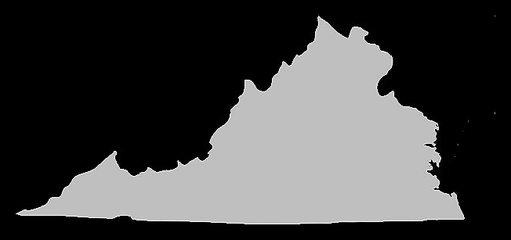

DISCRETE CONTOUR EVOLUTION OUTPUT

AREA OF CONTOUR FOR 6 DIFFERENT STEPS

STEP 1 : AREA = 68307.0

STEP 2 : AREA = 68312.5

STEP 3 : AREA = 68337.5

STEP 4 : AREA = 68457.0

STEP 5 : AREA = 68211.5

STEP 6 : AREA = 69156.5

**SOLUTION 2**

**CODE:**

import cv2

import numpy as np

import matplotlib.pyplot as plt

from random import randrange

import math

import scipy.signal

def cross_image(im1, im2):

im1_gray = np.sum(im1.astype('float'), axis=2)

im2_gray = np.sum(im2.astype('float'), axis=2)

im1_gray -= np.mean(im1_gray)

im2_gray -= np.mean(im2_gray)

return scipy.signal.fftconvolve(im1_gray, im2_gray[::-1,::-1], mode='same')

def stitch(img1, img2):

img1_gray = cv2.cvtColor(img1, cv2.COLOR_BGR2GRAY)

img2_gray = cv2.cvtColor(img2, cv2.COLOR_BGR2GRAY)

descriptor = cv2.ORB_create()

kp1, des1 = descriptor.detectAndCompute(img1_gray,None)

kp2, des2 = descriptor.detectAndCompute(img2_gray,None)

bf = cv2.BFMatcher()

matches = bf.knnMatch(des1, des2, k=2)

good = []

for m in matches:

if m[0].distance < 0.5*m[1].distance:

good.append(m)

matches = np.asarray(good)

if len(matches[:,0]) >= 4:

src = np.float32([ kp1[m.queryIdx].pt for m in matches[:,0] ]).reshape(-1,1,2)

dst = np.float32([ kp2[m.trainIdx].pt for m in matches[:,0] ]).reshape(-1,1,2)

H, masked = cv2.findHomography(src, dst, cv2.RANSAC, 5.0)

dst = cv2.warpPerspective(img1,H,(img2.shape[1] + img1.shape[1], img2.shape[0]))

dst[0:img2.shape[0], 0:img2.shape[1]] = img2

img3 = cv2.cvtColor(dst, cv2.COLOR_BGR2GRAY)

row, col = img3.shape

a = 0

i = col - 1

while True:

if img3[int(row*0.5),i] != 0:

a = i

break

i = i - 1

dst = dst[0:row, 0:a + 1]

return dst

img_ = cv2.imread("C:\Data\Software\ECE5554 FA19 HW3 images\Goodwin1.png")

img = cv2.imread("C:\Data\Software\ECE5554 FA19 HW3 images\Goodwin0.png")

img_p = cv2.imread("C:\Data\Software\ECE5554 FA19 HW3 images\Goodwin2.png")

c = stitch(img_, img)

cv2.imwrite("output.png",c)

d = stitch(img_p, img_)

cv2.imwrite("output1.png",d)

final1 = cv2.imread("output1.png")

final2 = cv2.imread("output.png")

e = stitch(final1, final2)

cv2.imwrite("output2.png",e)

print("Displacement between first and second image")

a = cross_image(img, img_)

b = np.unravel_index(np.argmax(a), a.shape)

print(b[1])

print("Displacement between merged image and third image")

a = cross_image(c, img_p)

b = np.unravel_index(np.argmax(a), a.shape)

print(b[1])

**RESULTS:**

**FOR GOODWIN IMAGE SET**

FIRST & SECOND IMAGE MERGED

DISPLACEMENT BETWEEN IMAGES

The column displacement between the pairs of images is 1012 between first and second image and 524 between merged and third image.

**FOR HOBBIT IMAGE SET**

FIRST & SECOND IMAGE MERGED

ALL 3 IMAGES MERGED

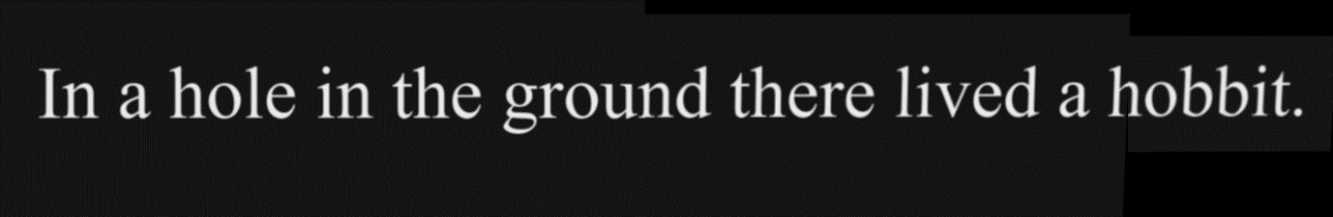

DISPLACEMENT BETWEEN IMAGES

The column displacement between the pairs of images is 496 between first and second image and 1236 between merged and third image.

**FOR BIGFOUR IMAGE SET**

FIRST & SECOND IMAGE MERGED

ALL 3 IMAGES MERGED

DISPLACEMENT BETWEEN IMAGES

The column displacement between the pairs of images is 1085 between first and second image and 1469 between merged and third image.

**Reference** : <https://towardsdatascience.com/image-stitching-using-opencv-817779c86a83>